AI Personal Assistant
A Project Report
Submitted by:
Adarsh Singh (221B024)
Aditya Sachan (221B029)
Laxmikant Shukla (221B220)
Under the guidance of:
Dr. Kunj Bihari Meena

MAY- 2026
Submitted in partial fulfillment for the award of the degree
of
BACHELOR OF TECHNOLOGY
IN
COMPUTER SCIENCE AND ENGINEERING
Department of Computer Science & Engineering
JAYPEE UNIVERSITY OF ENGINEERING & TECHNOLOGY, AB ROAD, RAGHOGARH, DT. GUNA - 473226, M.P., INDIA
DECLARATION

We hereby declare that the work reported in 8th semester Major project entitled AI Personal Assistant, in partial fulﬁllment for the award of the degree of B.Tech. submitted at Jaypee University of Engineering and Technology, Guna, as per the best of our knowledge and belief there is no infringement of intellectual property rights and copyright. In case of any violation, we will solely be responsible.

Signature of Students

Adarsh Singh (221B024)
Aditya Sachan (221B029)
Laxmikant Shukla (221B220)

Department of Computer Science and Engineering, Jaypee University of Engineering and Technology, Guna, 473226
Date: 12-05-2026

JAYPEE UNIVERSITY OF ENGINEERING & TECHNOLOGY
Grade ‘A+’ Accredited with by NAAC & Approved U/S 2(f) of the UGC Act, 1956
A.B. Road, Raghogarh, Dist.: Guna (M.P.) India, Pin-473226 Phone: 07544 267051,
267310-14, Fax: 07544 267011
Website: www.juet.ac.in

CERTIFICATE

This is to certify that the work titled “AI Personal Assistant” submitted by Adarsh Singh, Aditya Sachan and Laxmikant Shukla in partial fulfillment for the award of degree of Bachelor of Technology (Computer science Engineering) of Jaypee University of engineering & Technology, Guna has been carried under my supervision. As per best of our knowledge and belief there is no infringement of intellectual property right and copyright. Also, this work has not been submitted partially or whole to any other university or Institute for the award of this or any other degree or diploma. In case of any violation concern, students will solely be responsible.

(Dr. Kunj Bihari Meena)

Assistant Professor (SG)
Department of Computer Science and Engineering
Date:12-05-2026
ACKNOWLEDGEMENT

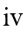
We take this opportunity to express our deep gratitude and most sincere thanks to our project supervisor Dr. Kunj Bihari Meena for giving the most valuable suggestions, helpful guidance and encouragement in the execution of this project work. We would like to thank our supervisor and coordinator for guiding us. Last but not the least we are grateful to all the team members of AI Personal Assistant.

Executive Summary

The AI Personal Assistant with Voice Cloning is an intelligent conversational system that allows users to interact with an AI assistant capable of replying in the user’s own voice. The project combines Artificial Intelligence, speech processing, and web technologies to create a personalized conversational experience.
The system enables users to record a short voice sample through the browser. The application analyzes the user’s voice characteristics such as pitch and gender and generates speech responses that resemble the user’s voice. The conversational replies are generated using Large Language Models like Google Gemini AI, while the speech synthesis is achieved through pitch-matched Edge-TTS and ffmpeg -based audio processing.
The architecture of the system consists of a Next.js frontend, a Node.js and Express backend API, and a Python Flask-based voice synthesis server. The frontend provides the user interface for recording audio and interacting with the assistant. The backend manages AI communication and voice profile handling, while the Flask service performs voice analysis and synthesis. The project demonstrates that personalized voice assistants can be developed using free tools and CPU-based systems without requiring expensive GPUs or paid APIs. The assistant responds in real time with low latency and provides an accessible, scalable, and efficient solution for voice-based AI interaction.

List of Figures

S. No | Figure No. | Figure Name | Page No.
1 | 3.1 | System Architecture | 18
2 | 3.3.1 | Level 0 DFD | 19
3 | 3.3.2 | Level 1 DFD | 20
4 | 3.3.3 | Use Case Diagram | 21
5 | 3.4 | Flow Chart | 22
6 | 5.4.1 | Home Page | 42
7 | 5.4.2 | Persona Selection and Conversational Interface | 43
8 | 5.4.3 | AI Response and Voice Interaction | 43


TABLE OF CONTENTS
Cover Page ………………………………………………………………………….. | i
Declaration of the Student ……………………………………………………............... | ii
Certificate of the Guide …………………………………………………………………... | iii
Acknowledgement ………………………………………………………………………. | iv
Executive Summary ………………………………………………………………………. | v
List of Figures …………………………………………………………………………….. | vi
Table of Contents …………………………………………………………………………. | vii

1. INTRODUCTION ………………………………………………………………………. | 8
1.1 Background of the Study....…………………………………………………… | 9
1.2 Problem Definition:………………………………………………………….. | 10
1.3 Project Overview …… ………………………………………………………. | 11
1.4 Scope of the Project ………………………………………………………….. | 12
2. LITERATURE SURVEY ………………………………………………………………. | 13
2.1 Existing System ………………………………………………………………. | 13
2.2 Limitations of Existing Work…….…………………………………………… | 14
2.3 Needs for Proposed System ………………………………………………….  3. SYSTEM ANALYSIS AND DESIGN…………………………………………………  3.1 System Architecture …………….……………………………………………  3.2 Design Methodology …………………………………………………………  3.3 Data Flow / UML Diagrams …………………………………………………  3.4 Flow Chart…………………………………………………………………….  4. Implementation and Testing ……………………………………………………………  4.1 Tools and Technologies Used ……………………………………………......  4.2 Implementation Details ……………………………………………………….  4.3 Algorithm ……………………………………………………………………..  4.4 Testing Methods ………..……………………………………………………..  4.5 Test Results…………………………………………………………………….  5. RESULT/ Discussion ……………………………………………………………………...  5.1 Result Analysis …………………………………………………………………...  5.2 Performance Evaluation ……….………………………………………………….  5.3 Discussion ……………………………………………………...............................  5.4 Project Snapshots …………………………………………………………………  6. CONCLUSION AND FUTURE SCOPE …………………………………………......... | 15  17  17  18  19  22  23  23  25  26  28  29  30  30  31  32  33  40
REFRENCES ……………………………………………………………………….……..  STUDENTS PROFILE …………………………………………………………….…….. | 42  43

Chapter 1

Introduction

AI Personal Assistant with Voice Cloning leverages artificial intelligence, speech processing, and conversational language models to simplify and modernize how users interact with virtual assistants. By combining deep learning-based voice analysis, automated speech synthesis, and intelligent prompt-driven conversation generation, the system enables users to communicate with an AI assistant that responds in the user’s own voice—without requiring advanced technical knowledge or expensive hardware resources.
Built on an intelligent processing and voice-driven architecture, the platform captures and analyzes voice samples, extracts meaningful speech characteristics such as pitch and tone, and generates personalized audio responses automatically. The system processes user input, performs conversational analysis using Large Language Models, and produces natural voice outputs through pitch-matched speech synthesis. It presents responses through an interactive web-based interface, ensuring clarity, responsiveness, and ease of use at every stage of interaction.
By integrating advanced conversational AI models with speech synthesis and voice-cloning techniques, AI Personal Assistant with Voice Cloning provides a fast, intuitive, and reliable end-to-end communication experience, empowering users to interact with AI systems in a more natural, personalized, and engaging manner.
Overall, AI Personal Assistant with Voice Cloning aims to transform the traditional conversational assistant workflow by combining intelligent language models with voice-personalization technology. It offers a robust, interactive, and automated solution that enables users to record voice samples, generate AI-powered conversations, receive personalized speech responses, and experience human-like interaction seamlessly, thereby enhancing accessibility, personalization, and efficiency across communication and virtual assistant applications.

Background of the Study:

Recent advancements in artificial intelligence have significantly improved the field of conversational systems and speech synthesis, particularly through the use of deep learning models and Large Language Models (LLMs). These technologies are highly effective in understanding human language, generating intelligent responses, and creating realistic voice-based interactions. However, traditional conversational assistants often lack personalization, as they rely on generic synthetic voices that do not reflect the user’s own speaking style or identity.

To address this limitation, the integration of voice analysis techniques with Large Language Models (LLMs) has emerged as a promising approach. Voice processing models handle speech analysis and synthesis, while language models generate meaningful and context-aware conversational responses, improving user engagement and interaction quality. This combination allows systems to not only communicate intelligently but also provide personalized voice responses that resemble the user’s own voice.

The proposed AI Personal Assistant with Voice Cloning system builds on this concept by combining voice analysis, pitch-matched speech synthesis, and AI-driven conversational intelligence. By converting voice recordings into structured voice profiles and integrating them with conversational AI models, the system generates clear, natural, and personalized audio responses. This approach improves realism, enhances accessibility, and creates a more immersive human-computer interaction experience.

Such systems have the potential to assist users in virtual communication, accessibility support, customer interaction, and intelligent digital assistance by providing faster, more natural, and highly personalized conversations. However, challenges such as voice accuracy, audio quality, real-time processing, and ethical considerations related to voice cloning must be addressed to ensure secure, reliable, and responsible deployment in real-world applications.

Problem Definition:

In today’s AI-driven digital environment, the ability to interact with intelligent conversational systems in a natural and personalized manner is becoming increasingly important across communication, productivity, and accessibility domains. However, many traditional virtual assistants struggle with limitations such as generic voice responses, lack of personalization, delayed interaction, and limited emotional engagement. For users seeking more human-like communication experiences, existing systems often fail to provide realistic and personalized voice interaction.
AI Personal Assistant with Voice Cloning addresses these challenges by leveraging artificial intelligence, speech processing, and language models to enable intuitive, automated, and personalized conversational interaction. The system simplifies voice-based communication, reduces dependency on generic synthetic voices, and enhances user engagement by generating responses in the user’s own voice—making AI interaction more natural, accessible, and immersive.

Key components of the problem include:

- Voice-Based Conversational Interaction: Using Large Language Models (LLMs) and conversational AI, the system understands user queries and generates intelligent, context-aware responses, enabling natural human-computer interaction without manual intervention.
- Voice Analysis and Cloning Pipeline: A structured voice-processing pipeline captures user voice samples, analyzes speech characteristics such as pitch and tone, and creates personalized voice profiles to support realistic speech synthesis.
- Automated Speech Synthesis: The system integrates speech synthesis technologies that convert AI-generated text responses into personalized audio replies, allowing users to hear responses in a voice closely resembling their own.
- Real-Time Interaction and Interpretability: With integrated conversational interfaces and audio playback, users can interact with the assistant in real time, view generated responses, and experience seamless voice-based communication in a clear and intuitive manner.

1.3 Project Overview
AI Personal Assistant with Voice Cloning is an innovative AI-driven system designed to enhance the way users interact with conversational assistants through intelligent integration of speech processing, voice-cloning techniques, and Large Language Models (LLMs). By combining deep learning-based voice analysis, automated speech synthesis, conversational intelligence, and personalized audio generation, the system enables users to communicate with an AI assistant that responds in the user’s own voice without requiring advanced technical knowledge or expensive hardware resources. Whether users provide voice recordings or text-based queries, the platform interprets speech inputs and generates structured conversational responses including intelligent replies, personalized synthesized audio, and interactive communication outputs that make human-computer interaction more natural and engaging.
The system operates through several key stages: accepting user voice samples, performing audio preprocessing and pitch analysis, extracting speech characteristics using voice-processing algorithms, and generating structured voice profiles from recorded inputs. This information is then integrated into a language model-based conversational pipeline, enabling the system to produce intelligent responses, personalized speech outputs, and contextual interactions. This approach allows the system to provide accurate voice matching, meaningful conversational understanding, and user-friendly communication experiences. Special attention is given to ensuring audio clarity, response reliability, modular architecture, and adaptability across different voice types and conversational scenarios.
Ultimately, AI Personal Assistant with Voice Cloning aims to improve conversational AI workflows by reducing communication barriers and enhancing personalization in digital interaction systems. Particularly useful for virtual assistants, accessibility support, customer interaction platforms, and intelligent communication systems, it provides a scalable and efficient solution for personalized voice-based AI interaction. The project also promotes interdisciplinary collaboration between artificial intelligence, speech processing, and software engineering, encouraging innovation in conversational AI and voice-personalization technologies. Challenges such as voice accuracy, background noise handling, ethical concerns related to voice cloning, and real-time performance optimization must be addressed to ensure reliable operation and broader adoption in real-world applications.

1.4 Scope of the Project
Scope of the project is as following:
1. Personalized Voice-Based AI Interaction: The project aims to develop an intelligent AI assistant capable of interacting with users through personalized voice responses using voice-cloning techniques. It focuses on generating natural and human-like communication by analyzing user voice characteristics such as pitch, tone, and speech patterns.
2. End-to-End Conversational Processing Pipeline: The system covers the complete workflow starting from voice recording, audio preprocessing, pitch analysis, conversational response generation using Large Language Models (LLMs), and final speech synthesis. This ensures a fully automated and efficient pipeline for personalized AI-based communication.
3. Intelligent Conversational AI through LLM Integration: A key scope of the project is to enhance conversational intelligence by integrating Large Language Models such as Google Gemini. The system processes user queries, maintains conversational context, and generates meaningful, human-like responses for interactive communication experiences.
4. Scalable and Modular Architecture: The system is designed with a modular architecture, allowing easy expansion to support advanced voice-cloning models, multiple conversational personas, multilingual interaction, and future AI integrations. This makes it adaptable for future virtual assistant and communication applications.
5. User Accessibility and Practical Application: The project emphasizes usability by providing a simple web-based interface that allows users to record voice samples, interact with the assistant, and listen to personalized audio responses easily. It aims to assist users in communication, accessibility support, customer interaction, and virtual assistance while remaining accessible to individuals with limited technical knowledge.

Chapter 2

Literature Survey

2.1 Existing System
Several systems and frameworks have been developed to automate conversational AI and voice-based interaction workflows, particularly those integrating speech processing models with language-based conversational systems for personalized communication and response generation. These systems aim to simplify human-computer interaction, especially in virtual assistance, accessibility support, and customer communication environments. Below are some common approaches observed in existing systems:
Voice-Based Conversational Assistant Systems:
Model: Large Language Models (LLMs), conversational AI frameworks, and transformer-based architectures.
Approach: Analyze user queries and generate intelligent conversational responses using natural language understanding and contextual reasoning. These systems rely on conversational datasets, prompt engineering, and cloud-based AI models to provide interactive and human-like communication experiences.

Voice Cloning and Speech Synthesis Systems:
Model: Neural Text-to-Speech (TTS) systems, Tacotron, WaveNet, XTTS, and Edge-TTS architectures.
Approach: Generate speech outputs that resemble human voices by analyzing speech patterns such as pitch, tone, and pronunciation. These systems use recorded voice samples and speech synthesis techniques to create realistic and personalized audio responses.

AI-Powered Personalized Assistant Systems:
Model: Conversational AI platforms, GPT-based assistants, and multimodal interaction systems.
Approach: Combine conversational intelligence with personalized interaction features to provide virtual assistance, task management, and voice-driven communication. These systems focus on improving user engagement, accessibility, and natural interaction through AI-generated responses.

Context- Aware Voice Interaction Systems:
Model: Metadata-driven speech pipelines, hybrid AI architectures, and intelligent response-generation systems.
Approach: Integrate voice characteristics, conversational context, and AI-generated outputs to provide adaptive and personalized communication experiences. These systems improve usability and interaction quality by combining speech synthesis, conversational reasoning, and contextual response generation for more natural human-computer interaction.

2.2 Limitations of Existing Work

Lack of Personalization in Traditional Voice Assistants:
Most existing conversational AI systems use predefined synthetic voices that sound identical for every user, reducing personalization and making interactions feel less natural and engaging.

High Dependency on Expensive Hardware:
Many advanced voice-cloning and speech-synthesis systems require GPU-based computation and large neural models, making them difficult to run on standard laptops or low-resource systems.

Limited Integration of Conversational AI and Voice Cloning:

Existing systems often focus either on intelligent text-based conversation or speech synthesis separately, but lack seamless integration of both technologies into a single interactive platform.

High Cost of Commercial Voice-Cloning Service:
Many professional voice-cloning platforms rely on paid APIs and subscription-based services, which limits accessibility for students, researchers, and small-scale developers.

Lack of Real-Time Interaction:
Some voice-cloning systems suffer from high latency and slow response generation, making real-time conversational interaction difficult and reducing user experience quality.

Limited Scalability and Adaptability:
Traditional conversational systems are often designed for fixed use cases and are not easily adaptable for multiple personas, multilingual interaction, or future AI model integration.

2.3 Needs for Proposed System

Personalized Voice-Based Interaction:
There is a strong need for a system that can provide personalized conversational experiences by generating AI responses in the user’s own voice, making communication more natural, interactive, and engaging.

Intelligent Conversational AI for Better Communication:
Traditional virtual assistants often provide generic and robotic interactions, so there is a need for a system that can generate meaningful, context-aware, and human-like conversational responses using advanced language models.

Efficient Handling of Voice and Audio Data:
With the increasing demand for voice-driven applications, there is a need for a system that can efficiently capture, preprocess, analyze, and synthesize voice data while maintaining low latency and high-quality audio output.

Integration of Voice Cloning and AI Conversation:
There is a need for a unified system that not only performs conversational response generation using Large Language Models but also synthesizes those responses in a personalized voice through voice-cloning techniques within a seamless pipeline.

User-Friendly and Scalable Solution:
The system should be easy to use for both technical and non-technical users, and scalable enough to support multiple conversational personas, multilingual interaction, advanced speech synthesis models, and future AI enhancements in virtual assistant applications.

Chapter 3:
System Analysis and Design
3.1 System Architecture
The system architecture of AI Personal Assistant with Voice Cloning is designed as a modular and intelligent pipeline that integrates conversational Artificial Intelligence, speech processing, and voice-cloning technologies to provide personalized and human-like communication. The architecture combines voice analysis, Large Language Models (LLMs), speech synthesis, and web-based interaction to create an efficient end-to-end conversational assistant capable of responding in the user’s own voice.
The process begins with the input layer, where the user interacts with the system through a web-based interface. The user can either record a voice sample or enter a text query. The voice sample is captured using the browser’s MediaRecorder API and uploaded to the backend server for processing. This stage ensures smooth and accessible interaction without requiring external recording software or specialized hardware.
The captured audio is then passed to the audio preprocessing module, which performs operations such as noise reduction, format conversion, normalization, and segmentation to ensure high-quality input for voice analysis. This preprocessing stage improves audio clarity and ensures accurate speech processing regardless of microphone quality or recording conditions.
After preprocessing, the voice sample is sent to the voice analysis module, which acts as the core speech-processing component of the system. This module performs pitch estimation, frequency analysis, and speech characteristic extraction using signal-processing techniques such as autocorrelation-based F₀ estimation. The extracted features include pitch, tone, and gender-related voice attributes. These features are then used to generate a structured voice profile for the user.
Following this, the system utilizes a voice profile and metadata generation layer, which converts the analyzed voice characteristics into structured metadata. This metadata includes information such as detected pitch range, selected speech synthesis voice, voice profile ID, and conversational preferences. This layer plays an important role in connecting the voice analysis system with the speech synthesis and conversational AI modules.
The structured metadata and user query are then passed into the prompt engineering and conversational AI module, where they are transformed into context-aware prompts for the Large Language Model. The system uses advanced conversational AI models such as Google Gemini to generate intelligent, human-like, and contextually relevant responses. This module ensures meaningful interaction by maintaining conversational context and generating dynamic replies based on user input.
The AI-generated response is then forwarded to the speech synthesis and voice-cloning module, which converts the generated text into personalized speech output. The system uses Microsoft Edge-TTS combined with pitch-matching and ffmpeg-based audio processing to synthesize speech that closely resembles the user’s own voice. This stage enables natural and immersive communication by preserving user-specific vocal characteristics during audio generation.
Finally, the output layer presents the generated response to the user through an interactive interface. The user can view the AI-generated text response and simultaneously listen to the synthesized audio reply. The frontend interface also supports persona selection, voice recording controls, audio playback, and conversation management, ensuring a smooth and user-friendly experience.
This architecture ensures a clear separation between voice processing, conversational intelligence, and speech synthesis, improving system scalability, maintainability, and performance. The modular design also allows future integration of advanced neural voice-cloning models, multilingual support, real-time streaming synthesis, and cloud-based deployment, making the system adaptable for future AI-powered communication and virtual assistant applications.

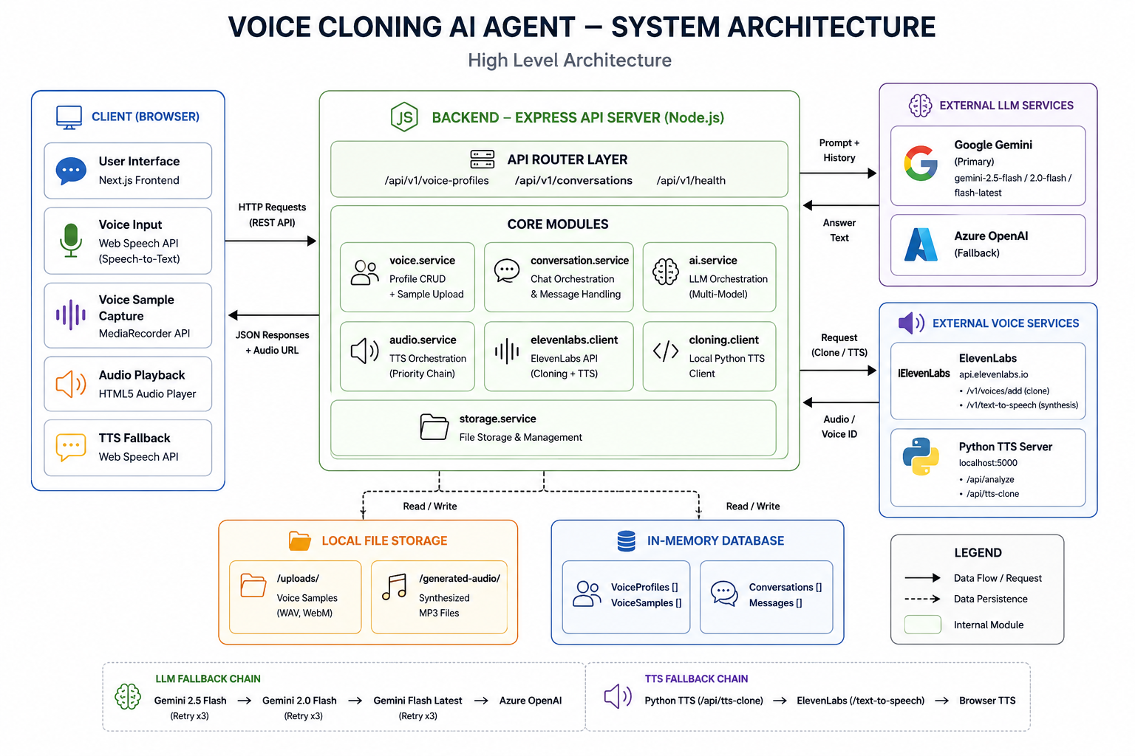
Fig: 3.1 System Architecture

3.2 Design Methodology
The design methodology of the AI Personal Assistant with Voice Cloning system follows a structured and systematic approach to ensure accuracy, efficiency, personalization, and real-time conversational interaction. It integrates speech-processing techniques, conversational Artificial Intelligence, and voice-synthesis technologies to provide both intelligent communication and personalized voice responses. The methodology is divided into multiple stages, each contributing to the overall performance, reliability, and usability of the system.

- Voice Data Acquisition: User voice samples are collected through a browser-based recording interface using the MediaRecorder API. The recorded speech is stored temporarily and used for voice analysis and personalized speech synthesis.

- Audio Preprocessing: The recorded audio is preprocessed through operations such as noise reduction, normalization, audio trimming, and format conversion to improve voice quality and ensure accurate speech analysis.
- Voice Analysis and Feature Extraction: Speech-processing algorithms are used to analyze the recorded voice sample and extract important characteristics such as pitch, tone, and frequency patterns. These extracted features help generate a structured voice profile for personalized speech synthesis.

- Voice Profile and Metadata Generation: The extracted voice characteristics are converted into structured metadata including pitch range, selected speech synthesis voice, and voice profile information. This metadata acts as a bridge between the voice analysis system and the conversational AI pipeline.

- Prompt Engineering: User queries and conversational context are transformed into structured prompts to guide the Large Language Model effectively. This stage ensures that generated responses remain context-aware, meaningful, and conversational.

- LLM Integration: A Large Language Model such as Google Gemini generates intelligent, human-like responses based on user input, conversation history, and contextual prompts. This module provides natural language understanding and conversational reasoning capabilities.

- Speech Synthesis and Voice Cloning: The AI-generated text response is converted into personalized speech using Edge-TTS and pitch-matching techniques. The synthesized audio is modified to resemble the user’s voice characteristics, creating a natural and immersive conversational experience.

- Output Generation: The system displays AI-generated responses and plays synthesized audio through a user-friendly web interface. Users can interact with the assistant in real time, listen to personalized replies, and manage conversations seamlessly.

3.3 Data Flow / UML Diagrams
Data Flow Diagrams (DFDs) represent how data moves through a system, showing inputs, processes, data stores, and outputs in a clear and structured manner for better system analysis and understanding.
UML Diagrams (Unified Modeling Language) are used to visually model system structure and behavior, including use case, class, and sequence diagrams.

3.3.1 Data Flow Diagram (Level 0)
Level 0 DFD represents the AI Personal Assistant with Voice Cloning system as a single process interacting with the user. The user provides a voice recording or text query as input, and the system processes it to generate intelligent conversational responses along with personalized synthesized voice output.
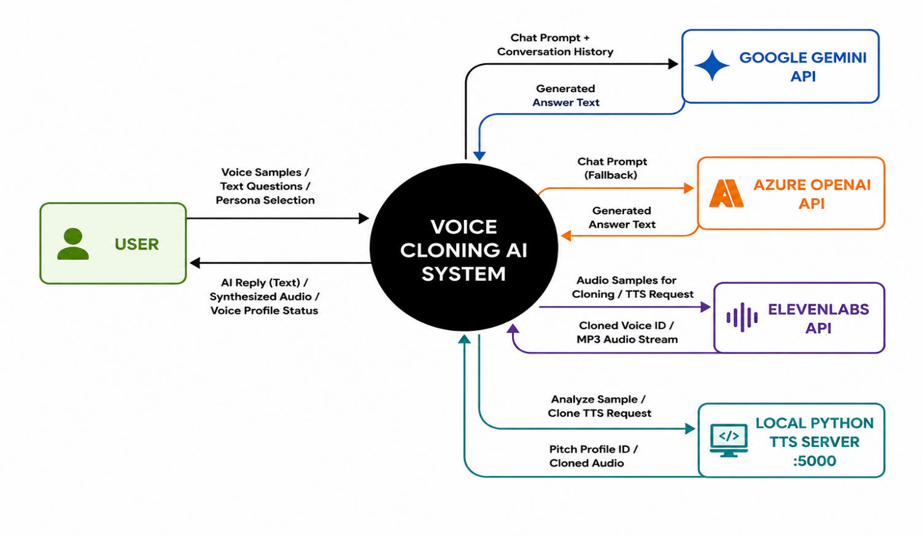
Fig 3.1 Level 0 DFD

3.3.2 Data Flow Diagram (Level 1)
This Level 1 DFD illustrates the internal workflow of the AI Personal Assistant with Voice Cloning system. The user provides a voice recording or text query through the web interface, which undergoes audio preprocessing and voice analysis before being processed by the conversational AI module. The system extracts important voice characteristics such as pitch and tone, generates structured voice metadata, and combines it with the user’s conversational input. This structured information is then transformed into a prompt and processed by the Large Language Model (LLM) to generate an intelligent conversational response. The generated response is passed to the speech synthesis and voice-cloning module, which produces personalized audio output in a voice closely matching the user’s own voice. Finally, the generated text response and synthesized speech are returned to the user through the interactive interface, ensuring both intelligent communication and personalized voice interaction.
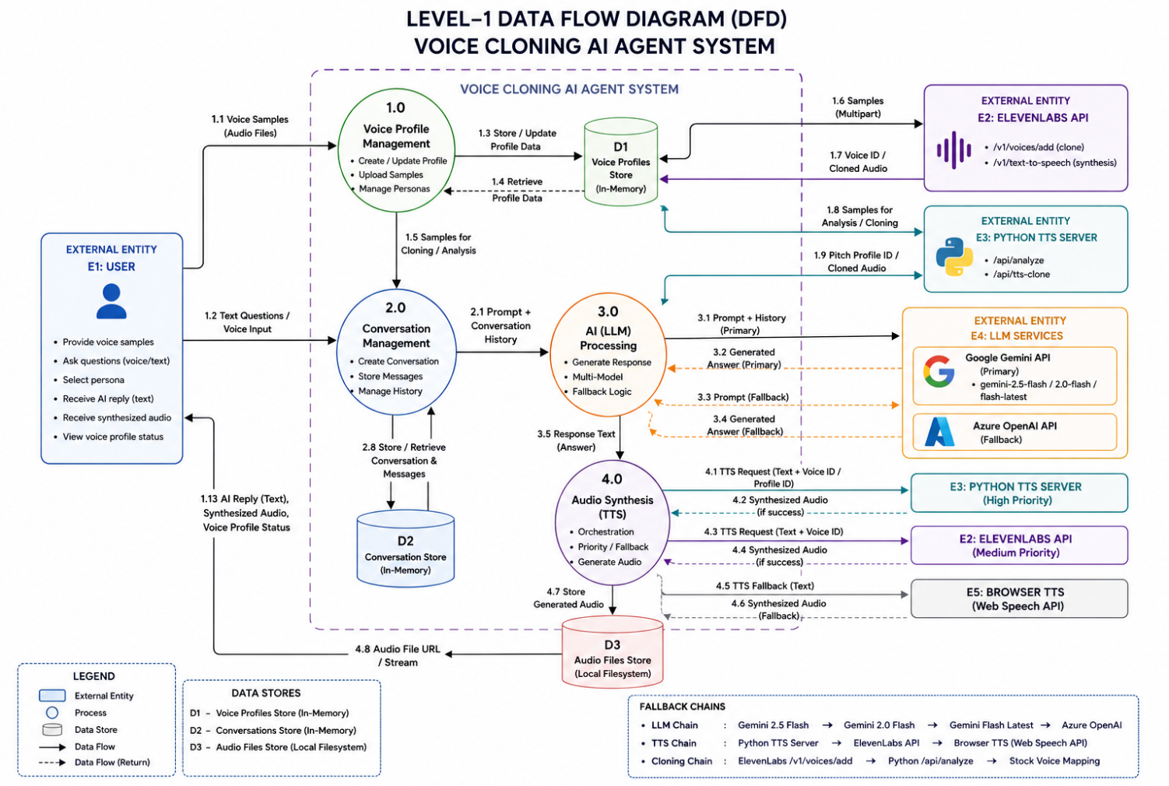
Fig 3.3.2 Level 1 DFD

3.3.3 Use Case Diagram
This use case diagram represents the interaction between the user and the AI Personal Assistant with Voice Cloning system. It shows the complete workflow from recording a voice sample or entering a text query to generating personalized conversational responses. The system processes the voice input using speech-analysis modules, generates structured voice metadata, creates conversational prompts, and produces intelligent AI-generated responses along with personalized synthesized voice output for user interaction and communication.
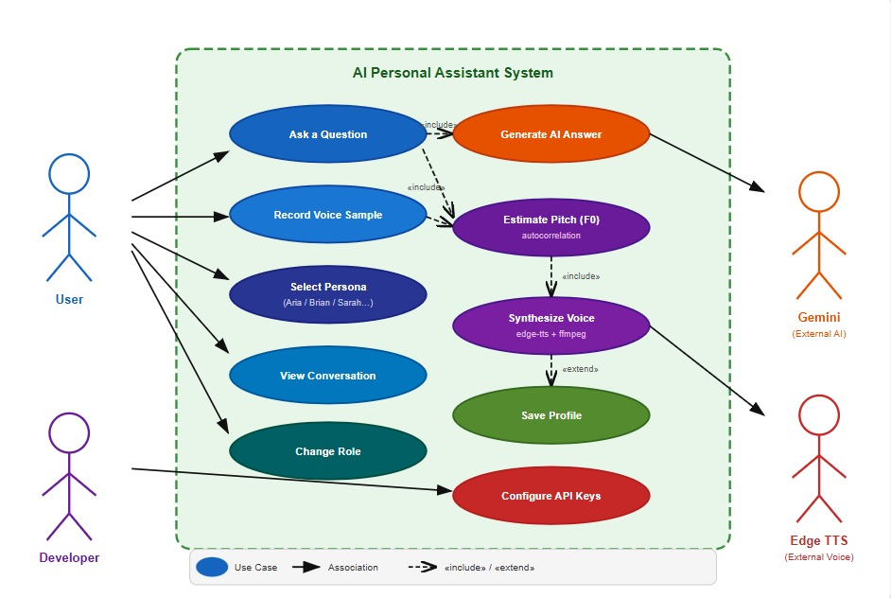
Fig 3.3.3 Use Case Diagram
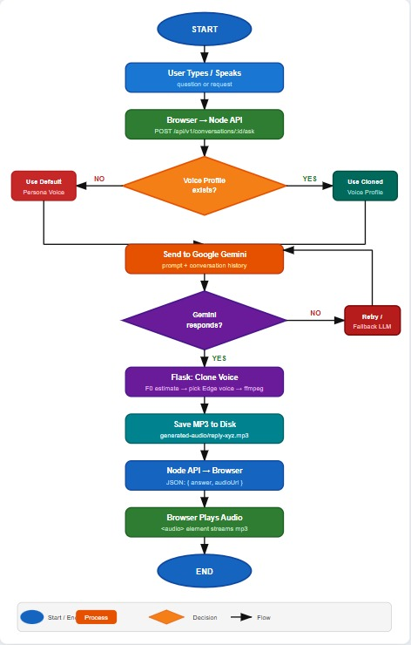
Fig 3.4 Flow Chart

Chapter 4

Implementation and Testing

4.1 Tools and Technologies Used

The development of the AI Personal Assistant with Voice Cloning system utilizes a combination of modern programming tools, speech-processing technologies, conversational AI frameworks, and web development technologies to ensure efficient performance, scalability, personalization, and real-time interaction.

- Programming Language: Python, TypeScript, JavaScript

Python is used for implementing the voice-processing and speech-synthesis components of the system. It provides powerful libraries for audio processing, pitch analysis, and AI integration. Python handles voice analysis, speech synthesis, audio preprocessing, and backend AI services efficiently.
TypeScript and JavaScript are used for frontend and backend web development. TypeScript improves code reliability and maintainability through static typing, while JavaScript enables dynamic web functionality and seamless API communication. Together, these languages support the development of a scalable and interactive AI assistant platform.

- Frontend Framework: Next.js and React

Next.js and React are used to develop the interactive frontend interface of the application. These frameworks provide fast rendering, reusable UI components, and efficient state management for real-time conversational interaction.
The frontend manages:
- Voice recording functionality
- Persona selection
- Chat interface
- Audio playback
- Real-time user interaction
The responsive and user-friendly interface improves accessibility and overall user experience.

- Backend Framework: Node.js and Express
Node.js with Express is used to build the backend REST API system that manages communication between the frontend, conversational AI services, and the voice-cloning module.
The backend handles:
- API request processing
- Conversation management
- Voice profile handling
- AI response orchestration
- Audio file serving
Express enables scalable and lightweight server-side development suitable for real-time AI applications.

- Conversational AI Integration: Google Gemini API
The Google Gemini API is used to integrate a Large Language Model (LLM) for generating intelligent and context-aware conversational responses. Based on user queries and conversation history, the model generates human-like replies that improve communication quality and interaction realism.
The integration ensures that conversational responses remain meaningful, adaptive, and contextually relevant, providing a more natural AI assistant experience.

- Speech Synthesis Engine: Microsoft Edge-TTS
Microsoft Edge-TTS is used for speech synthesis and voice generation. It provides high-quality neural text-to-speech voices capable of generating natural and expressive audio responses.
The system uses Edge-TTS combined with pitch-matching techniques to generate speech outputs that closely resemble the user’s voice characteristics. This enables personalized and immersive voice interaction.

- Audio Processing Libraries: NumPy, SciPy, FFmpeg
These tools and libraries are used for handling and preprocessing audio data before voice synthesis and playback.
- NumPy is used for numerical computation and signal analysis.
- SciPy is used for audio processing and pitch estimation algorithms.
- FFmpeg is used for audio conversion, normalization, format transformation, and pitch shifting.
Together, they ensure high-quality audio processing and efficient speech synthesis.

- Voice Analysis Module: Autocorrelation-Based Pitch Detection
The system uses autocorrelation-based pitch estimation algorithms to analyze recorded voice samples and extract important speech characteristics such as fundamental frequency (F₀), pitch range, and tone.This module helps generate structured voice profiles that are later used for personalized speech synthesis and voice matching.

- Web Audio and Recording APIs: MediaRecorder API
The browser-based MediaRecorder API is used for capturing user voice recordings directly from the web interface. It allows users to record voice samples without requiring external software or plugins.
The recorded audio is processed and uploaded to the backend server for voice analysis and synthesis.

- Environment Configuration: python-dotenv and dotenv
The python-dotenv and dotenv libraries are used to manage environment variables securely, including API keys, server configurations, and secret credentials.
These tools help separate sensitive information from the main codebase, improving security, maintainability, and deployment flexibility across different environments.

- Data Exchange Format: JSON
JSON is used as the primary format for structured data exchange between system components. It enables smooth communication between the frontend, backend APIs, voice-analysis modules, and conversational AI services.
Its readability and flexibility make it ideal for modern AI-powered web applications.

- Version Control System: Git and GitHub
Git and GitHub are used for version control, collaboration, and project management. These tools help track code changes, manage development workflows, and maintain project consistency during implementation and testing phases.
They also support collaborative development and simplify deployment and maintenance processes for the application.

4.2 Implementation Details

The implementation of the AI Personal Assistant with Voice Cloning system is designed as an end-to-end conversational pipeline integrating voice processing, speech synthesis, conversational AI, and web-based interaction. The backend is developed using the Node.js and Express framework, which efficiently handles HTTP requests, API communication, voice profile management, and audio processing. The system begins by initializing the conversational AI services, voice-cloning modules, and required libraries for speech analysis and audio synthesis. Technologies such as Google Gemini API, Edge-TTS, FFmpeg, NumPy, and SciPy are configured, while environment variables such as API keys and server configurations are securely managed using dotenv-based configuration systems. The application also manages static directories for storing generated audio files, uploaded voice samples, and temporary processing data, while the frontend interface is rendered dynamically using Next.js and React components.
When a user records a voice sample through the browser interface, the system first validates the audio format and ensures that the recording is suitable for processing. The audio sample is then converted into a standardized format and passed through preprocessing operations such as normalization, trimming, and noise reduction. The processed audio is analyzed using speech-processing algorithms to extract important voice characteristics such as pitch, frequency, and tone. Pitch estimation techniques based on autocorrelation are used to calculate the user’s fundamental frequency (F₀), which is later used for personalized voice synthesis. The extracted voice information is stored as structured metadata, including pitch range, selected synthesis voice, and voice profile ID.
The structured voice metadata is combined with user conversational input collected through the chat interface. User queries, conversation history, and contextual information are then transformed into structured prompts and passed to a Large Language Model (LLM) using the Google Gemini API. The LLM generates intelligent, context-aware, and human-like conversational responses based on the user’s input and selected conversational persona. Error handling and retry mechanisms are implemented to manage API failures, overload conditions, or network issues, ensuring fallback responses and uninterrupted interaction when external services are unavailable.
After generating the conversational response, the system forwards the generated text along with the voice profile information to the speech synthesis module. The voice-cloning component uses Microsoft Edge-TTS to synthesize speech in a voice closely matching the user’s characteristics. Additional pitch-shifting and audio-processing operations are performed using FFmpeg to align the synthesized voice with the user’s original pitch and tone. The generated audio is stored temporarily and linked to the active conversation session. This process creates a personalized and immersive communication experience where the AI assistant responds in a voice resembling the user’s own speech.
In addition to generating real-time conversational responses, the system supports audio persistence and session management. Uploaded voice samples and generated audio responses are stored securely with unique identifiers for efficient retrieval and playback. The backend also exposes REST API endpoints for handling voice recording uploads, conversation management, AI response generation, and synthesized audio retrieval. These APIs allow smooth communication between frontend and backend components and enable potential integration with external applications or services in the future.
Finally, the system ensures smooth user interaction through a modern web-based interface where users can record voice samples, interact with the assistant, select conversational personas, and listen to synthesized responses in real time. The frontend displays AI-generated text responses, conversation history, and audio playback controls in an intuitive and user-friendly format. The use of a modular architecture allows easy scalability and future enhancements, including integration of advanced neural voice-cloning models, multilingual support, streaming audio generation, and cloud-based deployment. This implementation effectively combines automation, conversational intelligence, personalization, and speech synthesis to create a realistic and engaging AI-powered virtual assistant experience.

4.3 Algorithm

The proposed system implements an end-to-end pipeline for personalized conversational interaction using a combination of speech processing, conversational AI, and voice-cloning technologies. It processes user voice input, performs voice analysis, generates intelligent conversational responses using a Large Language Model (LLM), and synthesizes personalized speech output, ensuring natural, interactive, and user-friendly communication for AI-powered virtual assistant applications.

1. START

2. Load Required Components
- Load conversational AI models and API configurations
- Initialize Node.js and Express backend server
- Initialize Python Flask voice-cloning service
- Load Google Gemini API for conversational AI
- Load Edge-TTS for speech synthesis
- Initialize audio-processing libraries such as NumPy, SciPy, and FFmpeg

3. Input Handling
- Accept voice recording or text query from user
- Accept conversational persona selection
- Validate audio format and input data
- Store temporary conversation and voice-session information

4. Audio Preprocessing
- Convert recorded audio into standard format
- Perform noise reduction and normalization
- Trim unnecessary silence from recording
- Convert audio into processable waveform data
- Prepare audio for voice analysis and synthesis

5. Voice Analysis and Feature Extraction
- Pass preprocessed audio to voice-analysis module
- Perform autocorrelation-based pitch estimation
- Extract speech characteristics:
→ Pitch (F₀)
→ Tone
→ Frequency patterns
- Identify closest matching speech synthesis voice
- Generate structured voice profile

6. Metadata Generation (Layer 0)
- Create structured voice metadata:
→ Voice profile ID
→ Detected pitch range
→ Selected synthesis voice
- Combine metadata with user conversational input
- Store conversation session details

7. Prompt Engineering
- Format user query and conversation history into prompt
- Add conversational context and persona instructions
- Prepare structured input for Large Language Model

8. LLM Processing (Conversational Response Generation)
- Send prompt to Google Gemini API
- Generate intelligent conversational response
- Maintain conversational context and continuity
- Apply retry and fallback mechanisms for reliability
- Produce human-like and context-aware output

9. Speech Synthesis and Voice Cloning
- Pass generated response to Edge-TTS engine
- Generate synthesized speech using selected voice profile
- Apply pitch-shifting using FFmpeg
- Match synthesized speech with user voice characteristics
- Generate personalized audio response

10. Output Generation
- Display AI-generated text response
- Play synthesized voice response
- Display active conversational persona
- Show conversation history through web interface

11. Audio Storage and Session Management
- Save generated audio in static directories
- Assign unique audio and conversation IDs
- Maintain temporary voice profile information
- Manage active conversation sessions securely

12. API Response
- Return AI-generated response via REST API
- Return generated audio URL for playback
- Provide conversation data through web interface or JSON response

13. END

4.4 Testing Methods
The testing phase ensures that the proposed system performs accurately, reliably, and efficiently under different conversational and voice-processing conditions. Various evaluation techniques are applied to measure conversational quality, voice synthesis accuracy, response latency, and overall system robustness. These methods help identify the strengths and limitations of the system. By testing under multiple voice samples, conversational scenarios, and user interactions, the system’s capability to provide natural and personalized communication is verified, ensuring it is suitable and dependable for real-world AI assistant and voice-based interaction applications.

- Standard Evaluation Approach: The system is evaluated using both conversational AI testing methods and system-level testing to ensure response quality, voice synthesis accuracy, and reliability. This approach helps validate both the conversational intelligence module and the overall voice-cloning pipeline.

- Voice Sample Testing: Different user voice samples are recorded and tested to evaluate the effectiveness of pitch analysis and voice-cloning functionality. The system is tested with multiple voice types, tones, and recording conditions to ensure consistent voice synthesis performance.

- Response Accuracy Evaluation: The conversational AI responses are evaluated to measure how accurately the system understands user queries and generates context-aware replies. This testing ensures that generated responses remain meaningful, relevant, and conversational.

- Voice Matching Evaluation: Voice matching tests are performed to analyze how closely the synthesized voice resembles the original user voice. Parameters such as pitch similarity, tone consistency, and speech clarity are evaluated to improve personalization quality.

- Latency and Performance Testing: The system is tested for response generation speed and overall processing efficiency. Metrics such as audio preprocessing time, AI response generation time, and speech synthesis latency are measured to ensure smooth real-time interaction.

- API and Integration Testing: API testing is performed to verify communication between frontend components, backend services, conversational AI modules, and the voice-cloning server. This ensures proper request handling, response generation, and audio delivery across the complete system pipeline.

- Manual Testing: Manual testing is performed to evaluate the quality of AI-generated conversations and synthesized speech outputs. This includes checking conversational clarity, voice naturalness, audio quality, and overall user experience during interaction.

- Edge Case Testing: Edge case testing is performed using noisy audio recordings, invalid inputs, low-quality microphones, long conversation sessions, and API failure scenarios. This helps evaluate system robustness, fallback handling, and reliability under unexpected conditions.

- User Interface Testing: The web interface is tested to ensure smooth user interaction, proper audio playback, accurate conversation display, and responsiveness across different devices and browsers. This improves accessibility and usability for both technical and non-technical users.

- Scalability Testing: The system is evaluated for scalability by testing multiple conversation requests, larger voice datasets, and simultaneous interactions. This ensures that the modular architecture can support future expansion and advanced AI integrations efficiently.

4.5 Testing Results
The testing results demonstrate that the proposed system performs effectively in both conversational response generation and personalized voice synthesis tasks. The evaluation confirms that the conversational AI model provides meaningful, context-aware, and human-like responses, while the voice-cloning module generates natural and personalized audio outputs. These results validate the system’s reliability, robustness, and practical applicability in real-world conversational AI and virtual assistant scenarios, ensuring both intelligent interaction and user-friendly communication experiences.
- Overall Performance: The system shows strong performance in generating intelligent conversational responses and personalized synthesized speech. It successfully integrates conversational AI with voice-cloning techniques, ensuring both conversational accuracy and realistic voice interaction.

- Conversational Response Accuracy: The Large Language Model (LLM) generates highly relevant and context-aware responses for user queries. The conversational module maintains continuity, understands user intent effectively, and produces meaningful replies across different conversational scenarios.

- Voice Cloning Performance: The voice-cloning module successfully analyzes user voice samples and generates synthesized speech closely matching the user’s pitch and tone characteristics. The generated voice responses provide a personalized and immersive communication experience.

- Response Latency: The system achieves real-time conversational interaction with an average response time of approximately 4–6 seconds, including voice processing, AI response generation, and speech synthesis. This ensures smooth and interactive communication without noticeable delays.

- Audio Quality and Clarity: The synthesized audio responses are clear, understandable, and natural-sounding. Pitch matching and FFmpeg-based audio processing improve speech quality and maintain consistency between the user’s original voice and generated speech output.

- API and System Reliability: The backend APIs and voice-processing modules perform reliably under different testing conditions. Retry mechanisms, fallback handling, and modular communication ensure stable operation even during API failures or network interruptions.

- User Interaction and Interface Testing: The web-based interface performs efficiently during voice recording, conversation handling, and audio playback. Users can smoothly interact with the assistant, switch personas, and listen to generated responses without usability issues.

- Scalability and Robustness: The modular architecture allows the system to handle multiple conversations, larger audio datasets, and extended interaction sessions effectively. The application remains stable under different usage scenarios and supports future expansion and feature integration.

- System Effectiveness: The integrated system provides both intelligent conversational interaction and personalized voice responses. This combination enhances user engagement, improves accessibility, and creates a more realistic and human-like AI assistant experience suitable for virtual assistance, communication support, and AI-powered interaction applications.

Chapter 5

Results and Discussion

5.1 Result Analysis

The results obtained from the AI Personal Assistant with Voice Cloning system clearly demonstrate the effectiveness of combining conversational Artificial Intelligence, speech processing, and voice-cloning technologies for personalized human-computer interaction. The conversational AI module plays a crucial role in understanding user queries and generating intelligent, context-aware responses. Based on conversational context, user input, and selected personas, the system produces meaningful replies that closely resemble natural human conversation. The system also maintains conversational continuity and adapts responses according to user interaction, which enhances the realism and engagement of the communication experience.
In addition to conversational response generation, the system integrates a voice-cloning and speech-synthesis module to generate personalized audio outputs. The voice-analysis pipeline extracts important speech characteristics such as pitch, tone, and frequency patterns from user voice samples. These features are then used to synthesize speech responses that closely resemble the user’s original voice. The generated audio responses are clear, natural, and interactive, improving personalization and making the AI assistant more immersive and user-friendly.
Furthermore, the integration of conversational AI with personalized voice synthesis ensures that the system not only provides intelligent interaction but also enhances emotional connection and communication realism. The ability to generate responses in the user’s own voice helps bridge the gap between traditional AI assistants and natural human communication. This makes the system more practical, engaging, and suitable for real-world applications such as virtual assistance, accessibility support, customer interaction, and AI-driven communication platforms, where both conversational intelligence and personalization are essential.

5.2 Performance Evaluation
The performance of the proposed AI Personal Assistant with Voice Cloning system is evaluated using standard conversational AI and system-level performance metrics to ensure responsiveness, reliability, and personalization quality. The conversational AI module generates highly relevant and context-aware responses, successfully maintaining meaningful interaction across different conversational scenarios. The system achieves smooth real-time communication with an average response latency of approximately 4–6 seconds, including voice processing, conversational response generation, and speech synthesis. This demonstrates that the system performs efficiently even on standard hardware without GPU dependency.
Further evaluation is carried out using voice-cloning performance analysis and speech-quality testing. The voice-analysis module accurately extracts user speech characteristics such as pitch and tone, while the speech-synthesis module successfully generates personalized voice responses that closely resemble the user’s original voice. The generated audio maintains good clarity, understandable pronunciation, and consistent speech quality. The system effectively performs pitch matching and voice adaptation, improving the naturalness and realism of synthesized speech outputs.
The reliability of the backend services and API communication is also evaluated. The REST APIs successfully manage conversation handling, audio uploads, voice processing, and generated audio playback without significant failures. Retry mechanisms and fallback handling improve robustness during API interruptions or network instability, ensuring uninterrupted user interaction. The frontend interface also performs efficiently during voice recording, audio playback, and conversation management, providing a smooth and user-friendly experience.
Apart from quantitative performance evaluation, the quality of conversational interaction is assessed qualitatively. The generated AI responses are observed to be meaningful, contextually relevant, and human-like, while the synthesized speech provides a realistic and personalized communication experience. Users can easily interact with the assistant, switch personas, and receive audio responses in real time, improving accessibility and engagement.
Overall, the evaluation results demonstrate that the system not only provides intelligent conversational interaction but also delivers realistic and personalized voice responses. This combination of conversational intelligence, speech synthesis, and user-friendly interaction makes the system highly effective for virtual assistant applications, AI-powered communication systems, accessibility support, and personalized conversational platforms.

5.3 Discussion
The proposed AI Personal Assistant with Voice Cloning system demonstrates strong performance by effectively integrating conversational AI, speech processing, and voice-cloning technologies into a unified framework. The combination of a Large Language Model (LLM) for intelligent response generation and a voice-synthesis module for personalized speech output enables the system to deliver both meaningful conversation and realistic voice interaction. This dual capability is particularly important in AI-powered communication systems, where both conversational intelligence and personalization significantly influence user engagement and overall experience.
The conversational AI module successfully generates context-aware and human-like responses, allowing users to interact naturally with the assistant. At the same time, the voice-cloning component enhances realism by generating speech outputs that closely resemble the user’s original voice characteristics. This personalized interaction improves communication quality and creates a more immersive experience compared to traditional virtual assistants that rely on generic synthetic voices.
Despite its strengths, the system has certain limitations that must be considered. The quality of synthesized speech depends heavily on the clarity of the recorded voice sample and background noise conditions. Low-quality recordings or noisy environments may reduce pitch estimation accuracy and affect voice similarity. Additionally, the system currently uses pitch-matching techniques rather than advanced neural voice-cloning models, which means that some aspects of the original voice such as timbre and emotional expression may not be perfectly replicated.
The performance of the conversational AI module also depends on external API services and internet connectivity. Network interruptions or API limitations may affect response speed or availability. Furthermore, ethical considerations related to voice cloning and AI-generated speech must be carefully addressed to ensure responsible and secure usage of the technology.
Future enhancements can further improve the system’s performance and applicability. These include integrating advanced neural voice-cloning models, supporting multilingual conversations, improving real-time streaming synthesis, enhancing emotional speech generation, and implementing secure user authentication systems. Additional features such as mobile application support, cloud deployment, and adaptive conversational memory can also improve scalability and usability.
Overall, the system proves to be efficient, scalable, and highly interactive, offering a promising solution for AI-powered conversational assistance and personalized communication. The project highlights the importance of combining conversational intelligence with speech personalization to create more natural, engaging, and human-like AI interaction experiences.

5.4 Project Snapshots
5.4.1 Home Page
The home page of the AI Personal Assistant with Voice Cloning system provides a user-friendly interface for recording voice samples, entering text queries, and interacting with the AI assistant. It guides users through voice recording, conversational input, and persona selection, enabling intelligent response generation and personalized voice synthesis efficiently and intuitively.
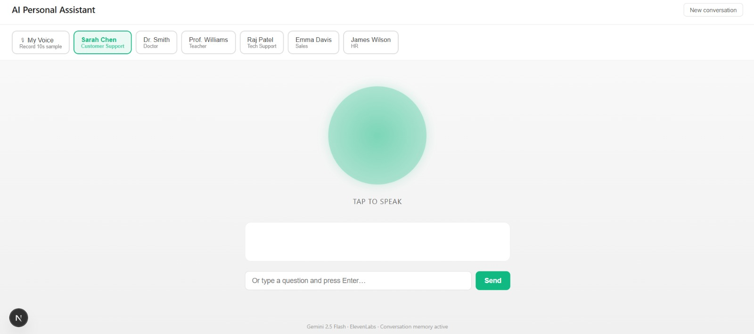
Fig 5.4.1 Home Page

5.4.2 Persona Selection and Conversational Interface
The Persona Selection and Conversational Interface feature allows users to interact with different AI assistant personas such as teacher, customer support, doctor, sales representative, and HR assistant. Users can select a preferred persona or use their own cloned voice profile for personalized interaction. The system processes user queries using a Large Language Model (LLM) to generate intelligent conversational responses and provides real-time interaction through an intuitive chat-based interface.

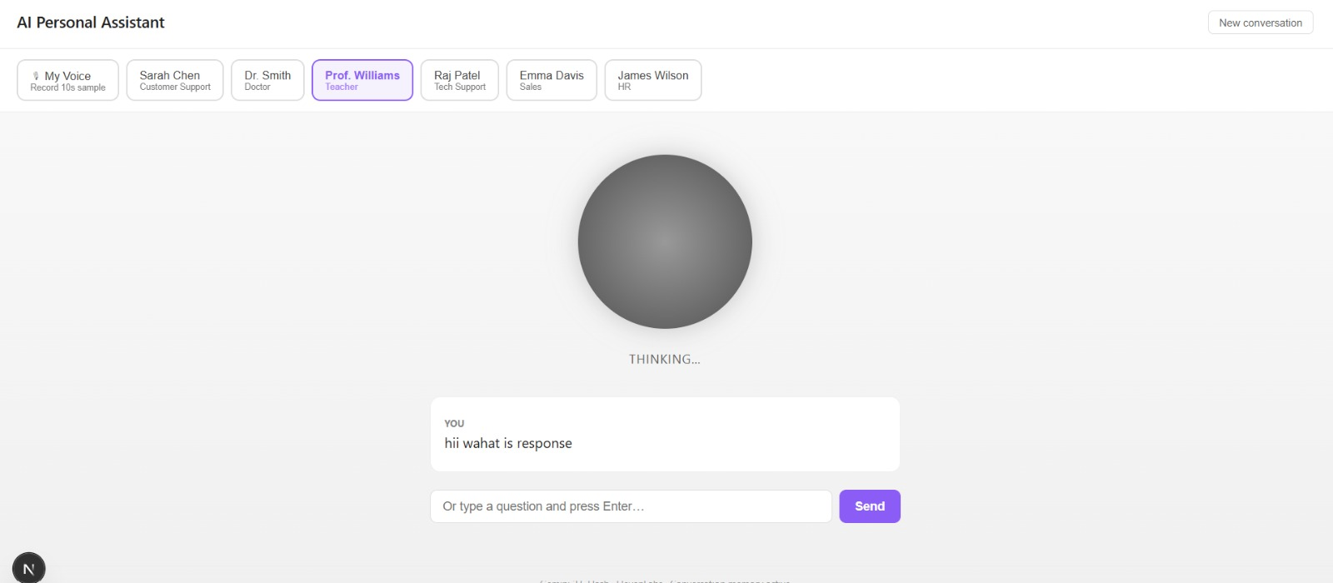
Fig 5.4.2 Persona Selection and Conversational Interface
5.4.3 AI Response and Voice Interaction
The AI Response and Voice Interaction feature allows users to communicate with the assistant through intelligent conversational queries and receive personalized responses in real time. The system processes the user’s input using a Large Language Model (LLM) and generates context-aware replies based on the selected persona. The generated response is then converted into synthesized speech, enabling natural and interactive voice-based communication with the AI assistant.
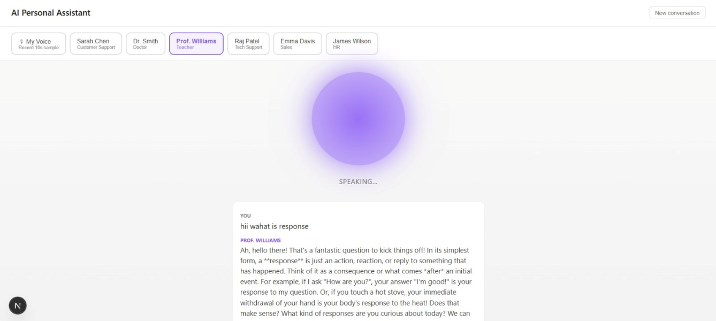
Fig 5.4.3 AI Response and Voice Interaction

Chapter 6

Conclusion and Future Work

Conclusion

In conclusion, the AI Personal Assistant with Voice Cloning system demonstrates significant potential in improving human-computer interaction by combining conversational artificial intelligence, speech processing, and voice-cloning technologies. The system effectively integrates a Large Language Model (LLM) for intelligent conversational response generation with speech synthesis and voice-analysis modules for personalized voice interaction.

Key aspects of the AI Personal Assistant with Voice Cloning include:
- Personalized Voice Interaction: The system analyzes user voice samples and generates AI responses in a voice closely matching the user’s original speech characteristics, creating a more natural and immersive communication experience.
- Conversational AI Integration: The Large Language Model generates intelligent, context-aware, and human-like conversational responses, improving communication quality and interaction realism.
- User-Friendly Interface: The system provides an interactive web-based interface that allows users to record voice samples, select conversational personas, interact with the assistant, and listen to generated responses easily.
- End-to-End Conversational Pipeline: The application covers the complete workflow from voice recording and preprocessing to conversational response generation, speech synthesis, and audio playback within a unified system.
- Real-Time Communication Support: The system achieves low-latency response generation and real-time interaction, enabling smooth and efficient conversational experiences suitable for practical applications.
- Improved Accessibility and Engagement: By combining conversational intelligence with personalized speech synthesis, the system enhances accessibility, user engagement, and communication effectiveness across AI-powered virtual assistant applications.

In summary, the proposed system improves the personalization, accessibility, and realism of AI-based conversational interaction. Although it is not intended to completely replace human communication, it serves as a powerful AI-driven communication and virtual assistant tool with strong potential for future advancements in conversational AI and voice-personalization technologies.

Future Scope

Here are some potential future enhancements and applications for the AI Personal Assistant with Voice Cloning:

Advanced Neural Voice Cloning: Integrate advanced neural voice-cloning models capable of replicating timbre, emotional expression, and speaking style more accurately for highly realistic speech synthesis.
- Multi-Language Conversational Support: Enhance the system to support multilingual interaction and speech synthesis, enabling users to communicate with the assistant in multiple languages.
- Voice-Based Command and Control: Enable full voice-controlled interaction where users can operate applications, devices, and smart systems through spoken commands and personalized voice responses.
- Mobile Application Development: Develop a mobile application that allows users to access the AI assistant anytime and anywhere, improving portability and accessibility for daily use.
- Real-Time Streaming Speech Synthesis: Implement streaming-based speech generation to reduce response latency and provide faster, more natural conversational experiences.
- Integration with Smart Devices and IoT: Connect the system with smart home devices, IoT platforms, and wearable technologies for intelligent voice-based automation and assistance.
- Emotion and Sentiment Recognition: Integrate emotion-detection systems to analyze user mood and generate emotionally adaptive conversational responses for more human-like interaction.
- Cloud-Based Deployment and Scalability: Deploy the system on cloud infrastructure to support large-scale usage, multi-user interaction, and enterprise-level conversational AI services.
- Enhanced Security and Voice Authentication: Implement secure voice authentication and user verification mechanisms to prevent misuse of voice-cloning technology and ensure ethical AI usage.
- Accessibility and Assistive Communication: Extend the system to support users with speech disabilities or communication challenges by providing personalized and assistive AI-driven communication solutions.

REFERENCE
- OpenAI, “GPT and Conversational AI Documentation.” https://developers.openai.com/api/docs
- FastAPI Documentation: https://fastapi.tiangolo.com/
- Google AI, “Gemini API Documentation.”: https://ai.google.dev/gemini-api/docs?utm_source=chatgpt.com
- Microsoft Corporation, “edge-tts: Microsoft Edge Text-to-Speech Service.”: https://github.com/rany2/edge-tts?utm_source=chatgpt.com
- Research references :
  - https://ritvik19.medium.com/papers-explained-an-introduction-to-vision-language-modeling-89e7697da6e3
  - https://www.nvidia.com/en-us/glossary/vision-language-models/
  - https://arxiv.org/abs/2304.00685

STUDENTS PROFILE



Name: Adarsh Singh
Enrolment No.: 221B024
Email: 221b024@juetguna.in
University: Jaypee University of
Engineering and Technology, Guna
Name: Aditya Sachan Enrolment No.: 221B029 Email: 221b029@juetguna.in  University: Jaypee University of Engineering and Technology, Guna | 
Name: Laxmikant Shukla  Enrolment No.: 221B220  Email: 221b220@juetguna.in  University: Jaypee University of Engineering and Technology, Guna | 

